

ADMISSION CUM REGISTRATION FORM FOR POST GRADUATE DIPLOMA LEARNING

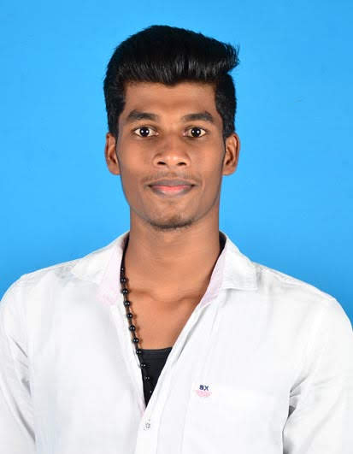ize photograph here

**Registration No**: ……………………………………………………………………………….

(For Office use only)

**Course Selected:** ………………………………………………………………………………

**Batch:** ………………………………………………………………………………

Please fill in the following details

1. Name: Suyambu Sakthivel B

**2. Father’s name: BalaSubramanian P**

3. Date of Birth: 14/05/1998 (DD/MM/YY) 4. Sex : Male Female

5. Address for Correspondence: 6/55, Vinayagar Kovil Street,

Elathagiri (post), Krishnagiri District, TamilNadu,

PIN – 635 108.

6. Telephone number: 8248525432 / 9965657431

7. E mail: suyambu145bgm@gmail.com



1. **Academic Qualification details :**

|  |  |  |  |
| --- | --- | --- | --- |
| **Exam Passed** | **Board/University** | **Year of passing** | **Percentage obtained** |
| **SSLC** | **State Board** | **2013** | **83%** |
| **HSC** | **State Board** | **2015** | **77%** |
| **B.Pharm** | **Vinayaka Mission’s** | **2019** | **74%** |

1. **Payment details :**

* Registration fee of Rs 25,000 is mandatory along with the application form.
* 2 passport size photographs, photocopies of the certificates.

**10. TERMS & CONDITIONS:**

ICBio Offers 100 % job assurance to every six month / one year course student, within 6 months of successful completion of the Course.



Student must have 75 % attendance for the job assurance.



ICBio shall not be liable to provide the job if the student fails to attend 4 interview calls.



Fee once paid cannot be refunded / adjusted / Transferred under any circumstances. Job obtained by any students with individual / own efforts will end up ICBio’s liability for providing the same.



*Declaration by the Candidate

I hereby declare that I have carefully read and understood the details of the above mentioned program and I have given the true and correct information while filling up the form. ICBio can take action in case any of the information given by me is found incorrect.

Name: Suyambu Sakthivel B

Signature